Parameters
There are 4 types of parameters
-positional
-Keyword
-default
-var-arg

Return x, y, z----is valid in python (returning multiple values)

Positional parameter
Def cal (a, b) :
----
----
Cal(100,50)
Cal(50,100) ------here position is very imp because first argument will be assigned to first Parameter in function

Keyword parameter
Def cal (a, b) :
----
----
Cal(a=100, b=50)
Cal(b=50,a=100) ------here position is not imp because we are sending keywords from
calling function

Cal(100, b=50)------valid
Cal(b=50, 100)-----Not valid-----after keyword argument , positional argument is no
valid
Cal(50, a=100)-----Not valid-----first argument is assigned to a and again we are passing second argument for a

Default parameter
Def wish (msg ,name=”Guest”): ------------if calling function doesn’t pass argument then default argument will be assigned
pass

Def wish (name=”Guest”, msg ): --------not valid, default argument should be always last one
pass

variable length parameter
def sum(*n)------this n is tuple

sum()-------------------valid
sum(10) -------------------valid
sum(10,20) -------------------valid
sum(10,20,30) -------------------valid

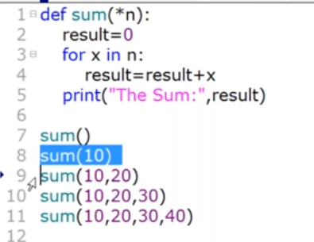
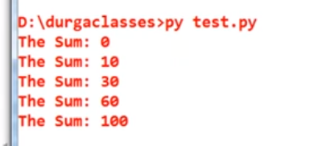

If we use both positional and var length argument then order doesn’t matter
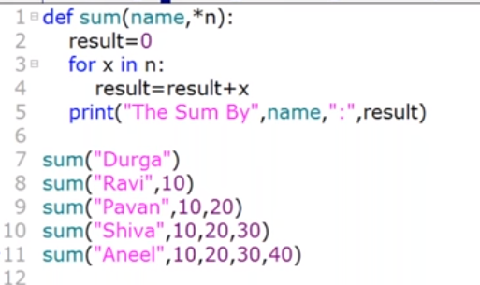
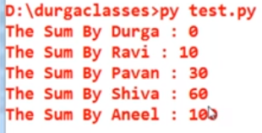
Def sum(*n, sum)------below case is valid
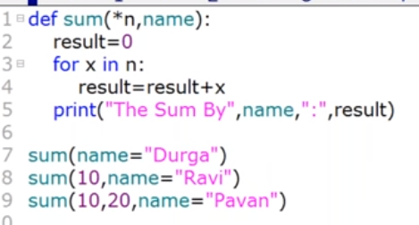

Keyword variable length arguments
If we use two stars (**), it will become dictionary
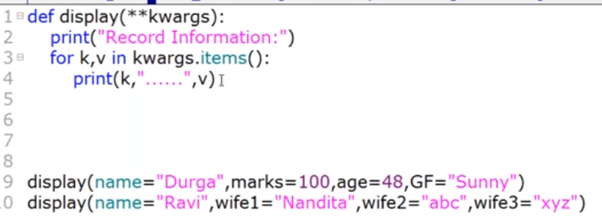
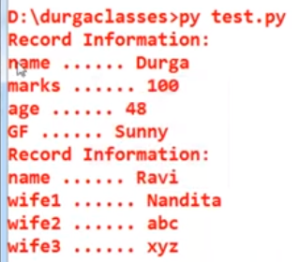

Thumb rule of arguments
  - If we are using keyword argument then they should be at last (keyword arguments cannot be passed before positional argument)
  - default argument should not come before positional arguments
  - *variablename is considered as tuple
  - If we pass *variablename with another positional argument then calling function should compulsory pass keyword argument corresponding to positional argument
  - **variablename is considered as dictionary.

Variables
-Global variables
-Local variables

Recursive function--------Function calls itself

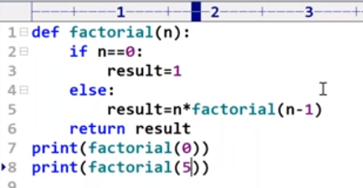
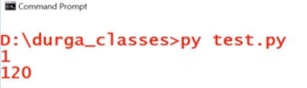

Anonymous function--------Function without name (instant use or only one time use)

S=lambda n : n*n ---------lambda is keyword, n is argument , n*n is returned value
Print (s(4))--------output is 16
Syntax : lambda argument : expression

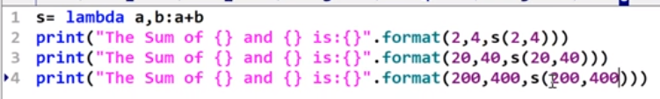
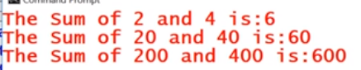
s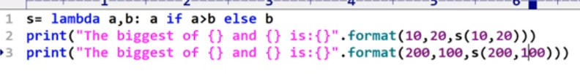

function can be argument to another function
below functions always accept another function as an argument
filter()
map()
reduce()

-filter()

Syntax : filter ( function, sequence)-----sequence can be tuple, list, set etc

In below code, filter function uses iseven function as argument and pass sequence (list l)
If iseven returns true, that value will be converted and stored into another list l1 and value will be discarded for false return

Argument function should always return true or false

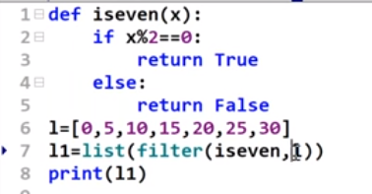

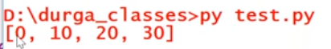

Another way is using lambda as argument

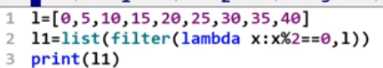

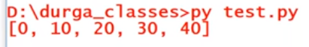

-map()

Syntax : map ( function, sequence)-----sequence can be tuple, list, set etc

For every element present in list l, perform double function
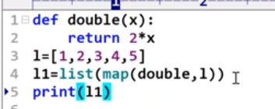

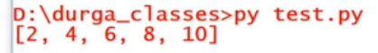

Same can be achieved using
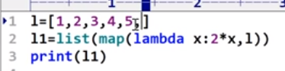

Another way with two sequences(number of elements in both sequence should be same, if any extra elements are there then they will be ignored

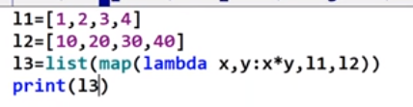
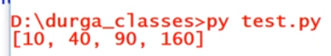

-reduce()

Syntax : reduce ( function, sequence)-----sequence can be tuple, list, set etc

Nested function -----function defined inside another function

Function inner is not available to call from outside of f1 function
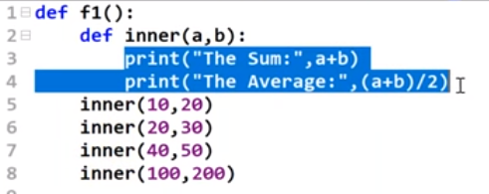

Inner function -----function returns another function

F1=outer()------------returned inner function assigned to F1
Return inner ---------parenthesis is not required

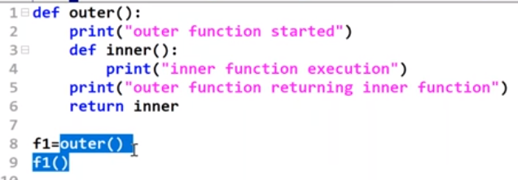

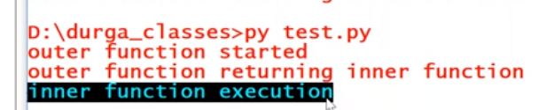

Function Decorators

Decorator help to make our code shorter and more pythonic

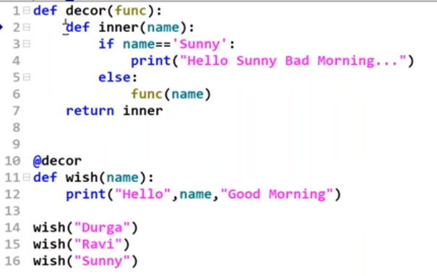

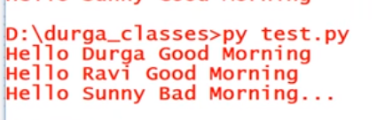

@decor indicates that there is decorator function----there is extended function
wish function is passed as argument for décor function
inner function uses the argument of wish function
func argument in décor function holds wish function

another way

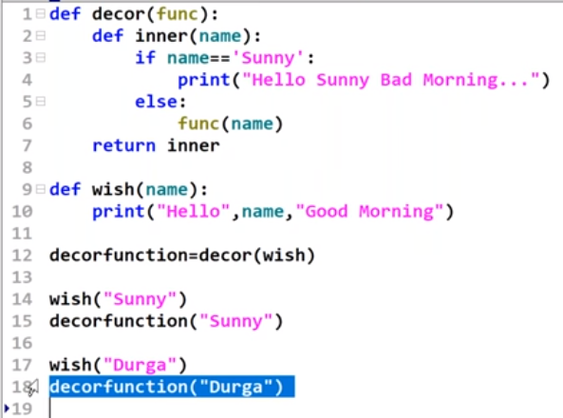
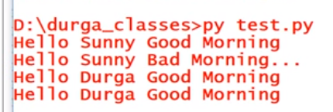

Explicitly calling décor function by passing wish will allow us to call wish separately and décorfunction separately

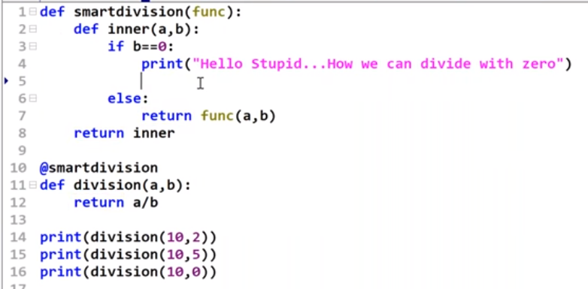

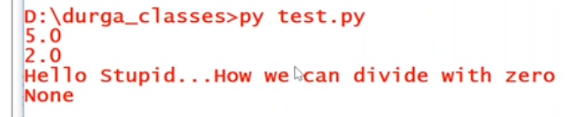

Modules ------group of Classes, functions and variables

Ways to import modules

Import module1
Import module1 as m1
from module1 import add
from module import *
from module1 import add as a

reload module
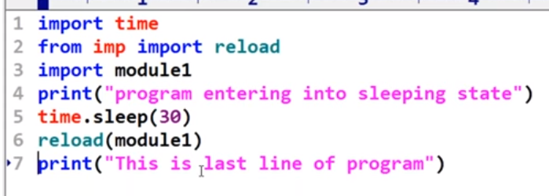

dir()---- gives member of current module

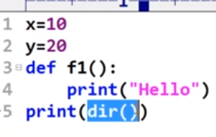

dir(module name) ---- gives member of specified module

Special variable __name__
------------------------------------

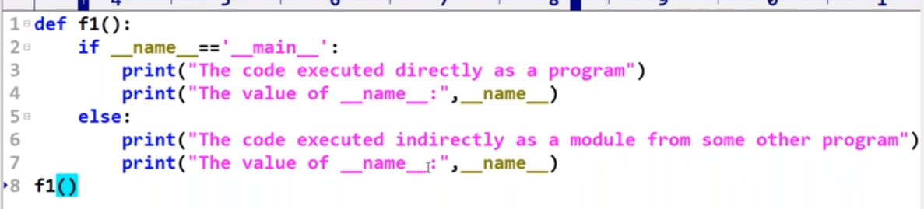
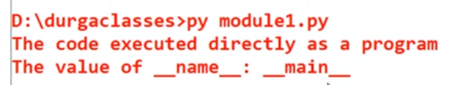

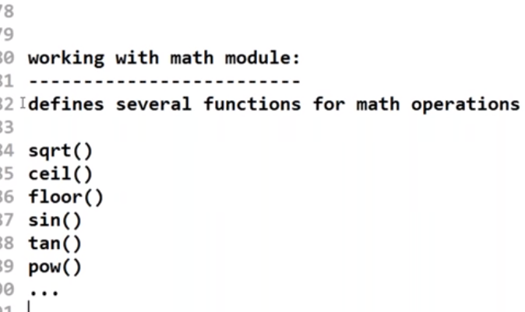

Math module

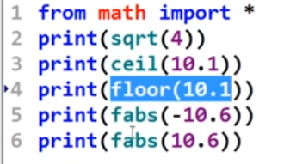

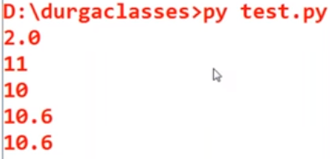

Random module

random()------generates random floating number in between 0 to 1 ….0<x<1
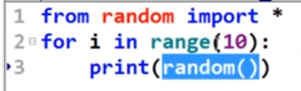

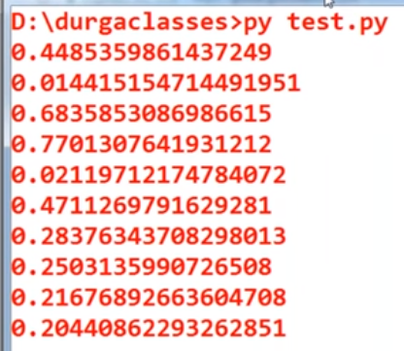

randint(1,100)----------generate int value between 1 to 100

uniform(1,100)--------generate float value between 1 to 100

randrange(start, stop, step)
start optional, default 0
step optional, default 1

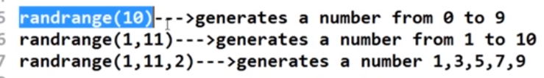

Choice()

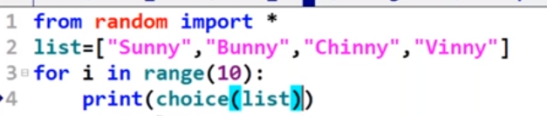

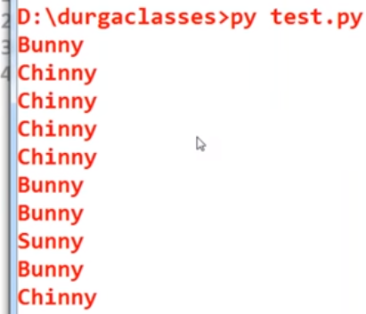

Prints 6 digit alphanumeric
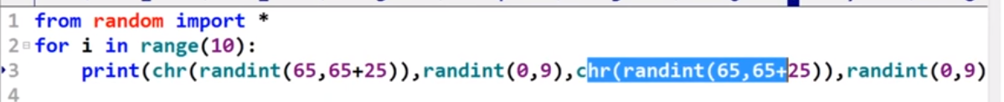

Prints two digit random number

